Fenciful Gallery – Saint Hill Street

Location: 18 Saint Hill Street
The transport hub planned for the corner of Taupō Quay and Saint Hill Street offers a point of connection for our community, accessible public transport and a rest stop for travellers. Alongside the creative design integrated into bus shelters and footpaths at this hub, a fenced area (below) will have artworks on display by and for the community.
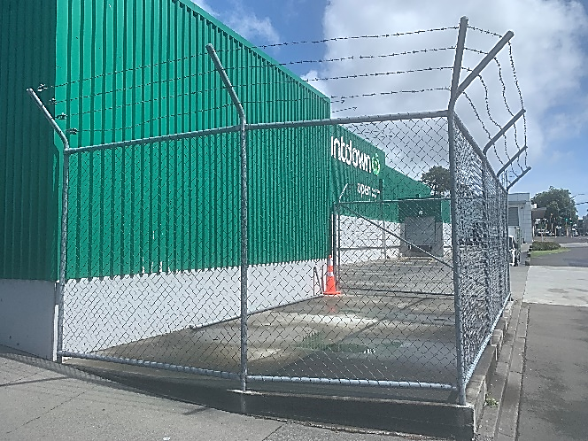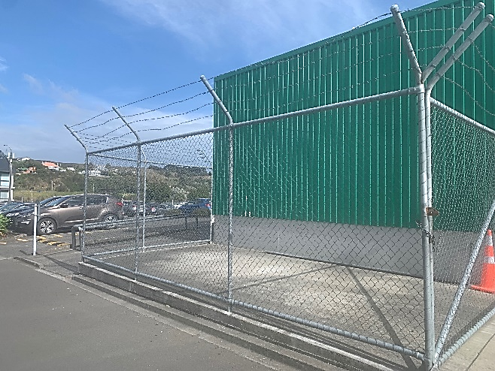
Design submissions will be printed on one of five A0 corflute panels installed on the fence. Artists have the opportunity to submit a design for one of five panels, which will feature at the site until the year’s end and must reflect the themes below.

Note:
- Artists can contribute existing or new artworks.
- Artists may apply for this and the Glow Gallery opportunity, however artworks submitted must be different and link to the site-specific themes stated in each brief.

Themes:
- Public transport: this corner of Taupō Quay and Saint Hill Street will support public transport in Whanganui, tying in with Te Ngaru; The Tide bus service, launched in 2023. The transport hub will acts as a key connection point to other areas of Whanganui, which encourages active and public transport.
- Our natural environment or Te Taiao
Whanganui’s natural environment has been a source of inspiration for many artists and the surrounding plantings to be installed at the transport hub welcomes artworks that relate to our flora and fauna. What flora or fauna would you like to see more of in our town centre?

Specifications:
- Colour palette must have warmer tones to connect with the surrounding beautification planned for the area and contrast well against the green wall behind the fence.
- The final design must be submitted as a PDF or TIFF file format.
- If submitting as a PDF:
- Try not to use a mix of CMYK and RGB colours
- Make sure to convert any text to shapes
- All images and effects (shadows, transparencies and glows) must be rasterised to at least 150dpi
- If submitting as a TIFF,
- CMYK or RGB can be used
- Ensure the image is at least 150dpi

- The final design must be A0 landscape
- The final design must include 20mm bleed all around

Proposals must include the following:
- Concept description – What is the main idea behind your artwork and how does it relate to one or both of the two themes?
- Full colour sketch – this can be digital or by hand
- Examples of previous work (if available)

All proposals must be emailed to streetsforpeople@whanganui.govt.nz

Deadline: Friday 26th April

If selected:
- An artist fee of $500 will be paid per design.
- Payment will be made once an artwork fulfilling the brief and design specifications has been submitted. An invoice and bank detail verification is also required for payment.
- The artist will remain the owner of their intellectual property however; Council may reproduce their submitted final design in promotion for various public art or place making projects.

